**Existential Restrictions**

(Some Restrictions or Some Value Restrictions)

What is Existential Restriction:

Existential restrictions are the most common type of quantifying restriction find in OWL ontology. That means it’s really important to know it very clearly.

*An existential restriction describes the class of individuals that have at least one kind of relationship along a specified property to an individual that is a member of a specified class.*

***restriction(hasFatContent someValuesFrom FatContent)***

Taken from “A Heuristic Approach to Explain the Inconsistency in OWL Ontologies Hai Wang, Matthew Horridge, Alan Rector, Nick Drummond, Julian Seidenberg”

<https://protege.stanford.edu/conference/2005/slides/5.3_Wang_protege11.pdf>

When it come to this point still the term existential restriction is not clear for me. Don’t look at Description Logics Syntax in this point your hair may terns into gray :P

Let’s look at the existential restrictions in a visual representation

In the Practical Guide to Build OWL Ontologies Using Protégé 4 and CO – ODE Tool Edition 1.3 they have describe existential restriction as

*An existential restriction describes a class of individuals that has* ***at least one******(some)*** *relationship along a specified property to an individual that is a member of a specified class.*

In their example they have mention

***hasBase*** *some* ***PizzaBase*** *describes all the individuals that have at leat one relationship along the* ***hasBase*** *property to an individual that is a member of the class* ***PizzaBase***

Luckyly they have add below sentence in their description <3

*In more natural English, all of the individuals that have at least one pizza base*

I know, if you are a beginner you may have a little confusion because you do not have any idea about the class hierachy and object property hierachy of the pizza ontology.I am doing the Exercise 16 of the practicle guide and look at the two hierachys I have created inside protégé

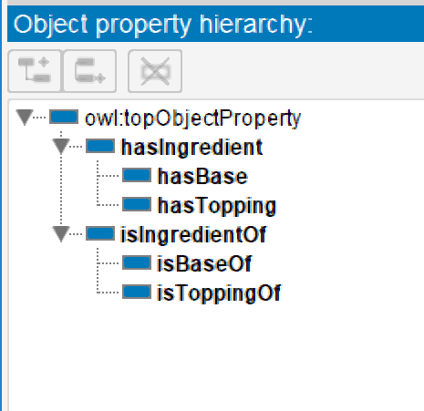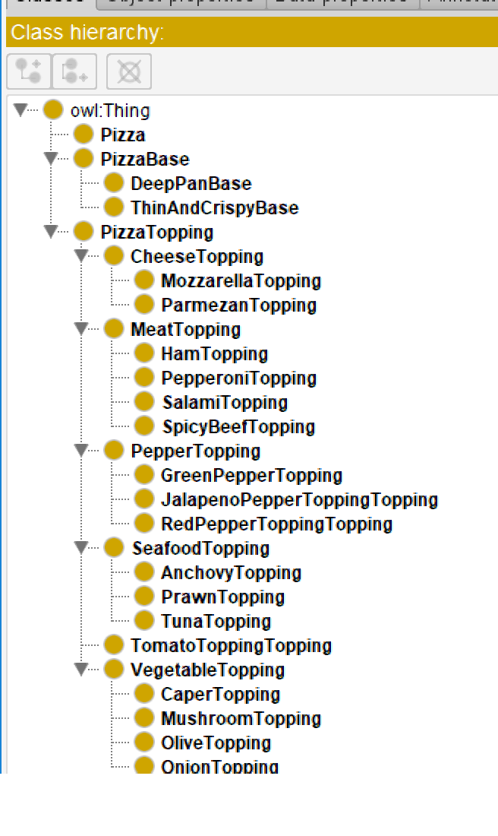

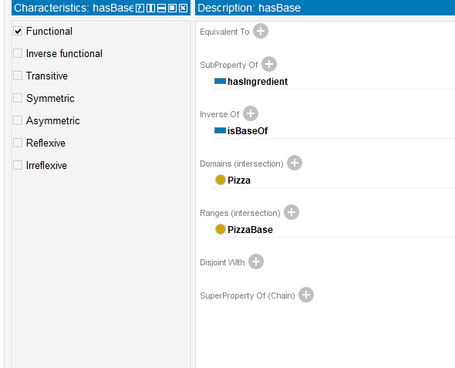

If you are dealing with dbms (Entity Relationship) you may familiar with terms like **at most one** and **at least one**

Here **at least one** indicate **1 or more** ; simply we can call it as **“some”**

Okay, so far, we were just looking at what others say and their examples regarding the existential restriction. Let’s move on to our shoe ontology. Please remember this is the most important part of our discussions Here we are sorting each description and example we have discussed earlier

In our ontology we need to implement the below logic (restriction)

“For something to be a member of our class call “AthleticShoe” it needs at least one (in OWL they identify it as **some**) associated heel as component.”

We can achieve this logic using existential restriction. In OWL we are specifying our restriction along the property. When we go through the logic statement, we can identify “Heel” is the filler class.

**SOME**

**FILLER CLASS**

**When we apply these things together into our class “**AthleticShoe**” it’s called the existential restriction**

**PROPERTY**

**AthleticShoe**

**Heel**

**hasComponent**

Existential Restriction

Filler Class

Property

**hasComponent** some **Heel**

Hope you have clearly understood what it means by Existential Restriction. I do this because I love blogging .I always encourage you to read and go through the contents in original documents because when you learn something clarity is the most important aspect your speed is not a huge issue unless you have to reach a deadline.